CineConcert NOSFERATU

F.W. Murnau's masterpiece with the new, powerful piano score by Markus Horn.

NOSFERATU
Silent film, Germany 1921
Digitally restored complete version 2006
With new piano soundtrack by Markus Horn
Running time: approx. 94 minutes

THE FILM

- digitally restored version of 2006 (running time approximately 94 minutes)
- available on DVD, Blu-ray or Media File
- Screen, video beamer and playback device needed
- Languages: English version with English intertitles, German version with German intertitles and optional subtitles in english
- More languages are available on request
THE INSTRUMENT

- The CineConcert will necessarily require a tuned grand piano. The instrument must be technically / mechanically in perfect condition to achieve the best result of film and music. An upright piano or a digital piano is not suitable for this purpose.
- The instrument should be placed so that the screen is visible from the instrument's position (see stageplan).
- The front part of the piano (around the keyboard) should be illuminated by a light spot.
- For major events (eg open air), amplification could be necessary.

FILM LICENSING

- For the screening of NOSFERATU in the USA a license must be purchased in advance of the event from Kino Lorber. The exact cost of this will depend on several factors, e.g. the number of paying spectators.

- Contact (USA):
Gary Palmucci
Vice President, Theatrical Distribution
Kino Lorber Films
333 W 39 St. Ste 503
New York NY 10018
Phone: 212 629 6880
E-Mail: gpalmucci@kinolorber.com

- For screenings in Europe please contact:
Friedrich-Wilhelm-Murnau-Stiftung
Patricia Heckert
Phone: +49 611 - 9 77 08 - 45
Fax: +49 611 - 9 77 08 - 19
E-Mail: verleih@murnau-stiftung.de

STAGEPLAN

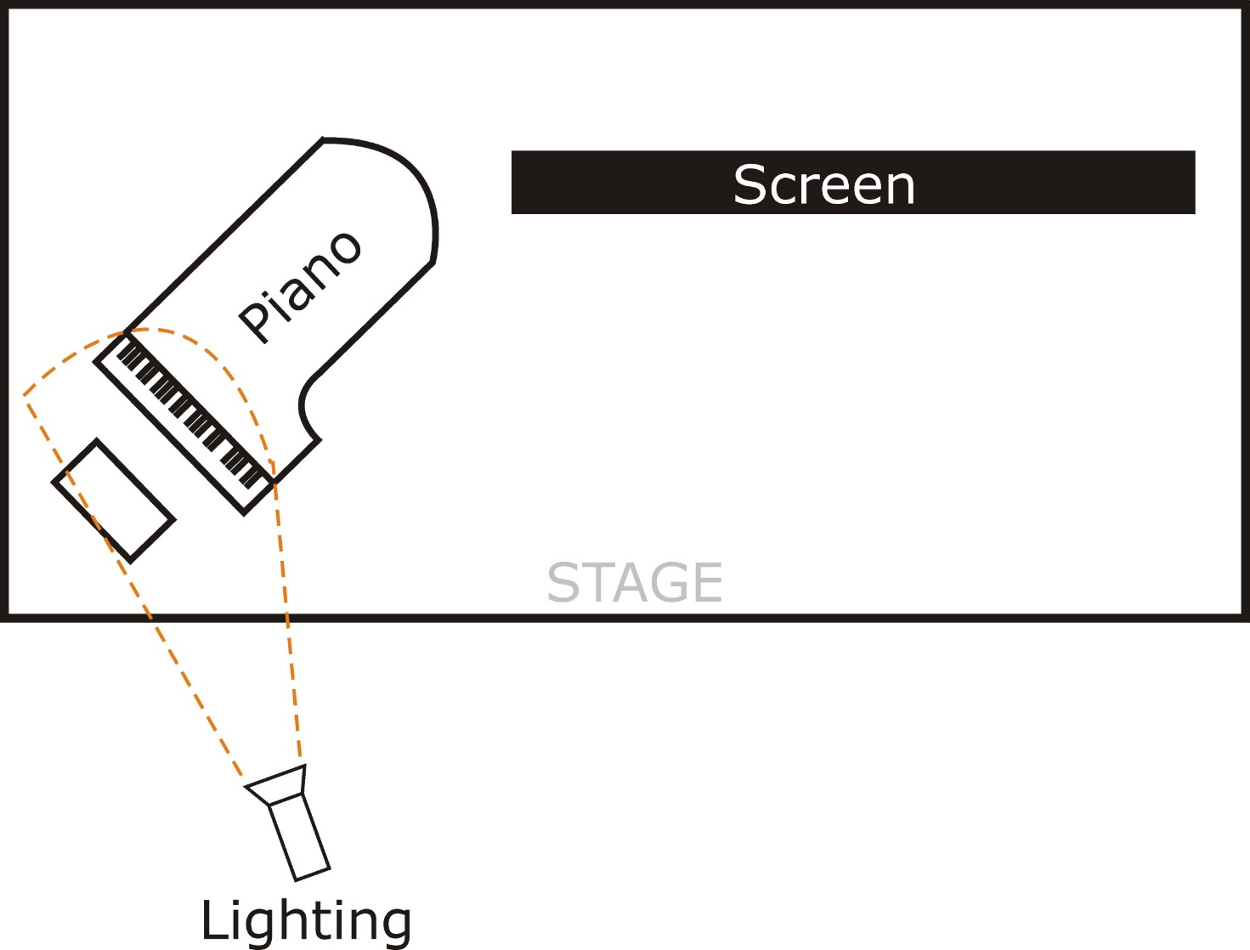

CONTACT

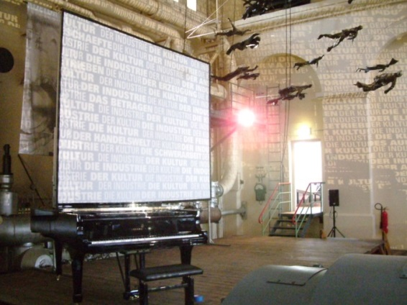 | Markus Horn  Droste-Hülshoff-Weg 60  D-30629 Hannover  Tel.: ++49 511-2831722  Fax: ++49 511-2281780  Mobil: ++49 173-6209591  Email: info@markushorn.de  Web: www.markushorn.de
www.nosferatu.markus-horn.net

